Thank you for contacting me.
The installation steps are as follow.

1. Open File>Options>Trust Center>Trust Center Settings…
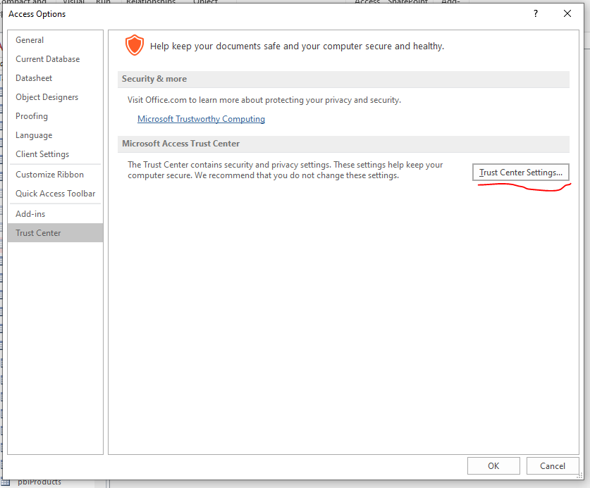
- Allow add-ins
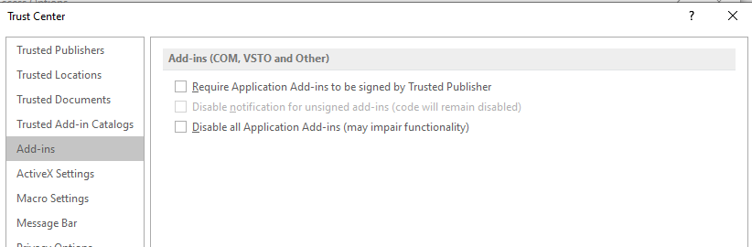
- Allow macros
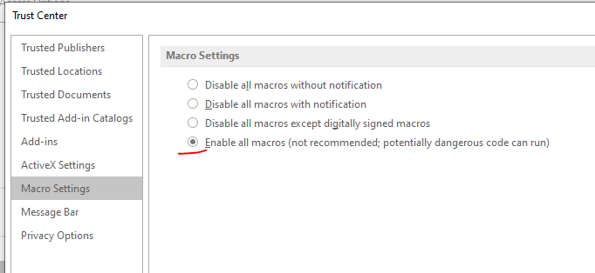

2. Install add-in as Administrator
a- Open MsAccess.exe as Administrator
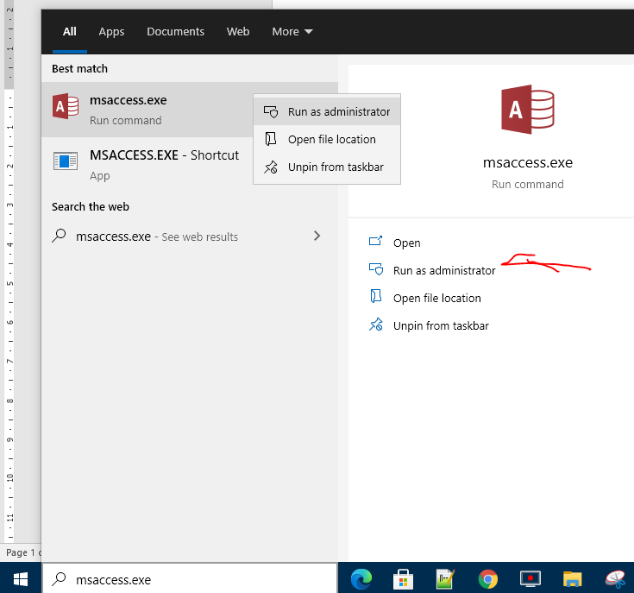
b- Install add-in
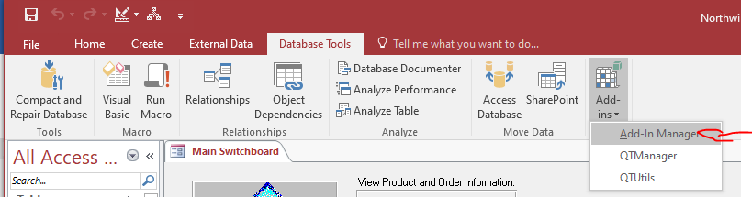

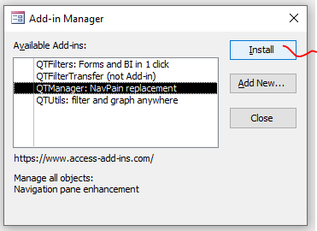

If the installation is successful, you will see an X to the left of the add-in name.
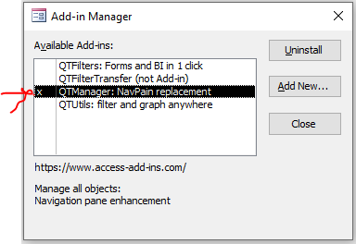

3. Reopen Access and load add-in (now it should be in the list of available add-ins)
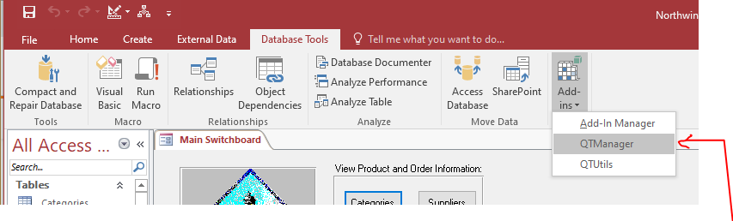
If you get an error the first time you load the add-in, please reopen Access as usual, then load the new add-in before loading any other add-in.
If there is still a problem, please provide me a screenshot and your country name.
Thanks.
Arie.
Icad01@gmail.com

Please check that the table QL_Objects was created
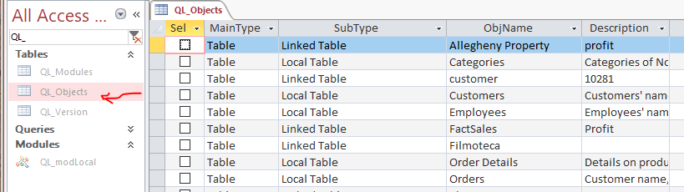
And that the VBA code is compiling without any error:
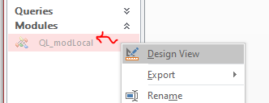
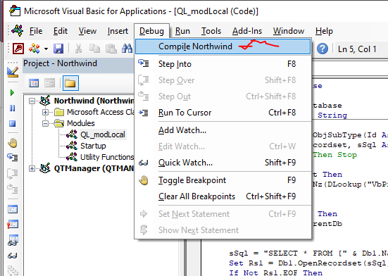
If it’s grey, that’s fine.
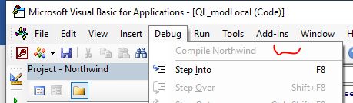

Please delete all QL_* and QG_* objects and run the add-in again (it will recreate the objects again)
Then make sure that the value in field VbProject (Northwind in this example)
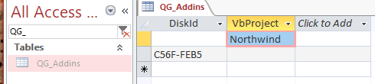
Is the same as the current opened access file VBA project name. Each file have a different VBA project name, and sometime the add-in setup pick the wrong one, especially if many files are opened or many add-ins are loaded at the first load. If it is not the same name, you can change manually the VbProject field value in the QG_Addins table to be the same, Northwind in this example.
